[http://www.channel4.com/news/no-fly-britain-air-travel-for-disabled-passengers](http://www.channel4.com/news/no-fly-britain-air-travel-for-disabled-passengers" \t "_blank)



Figure : httpaviationhumor.netaisle-seat#

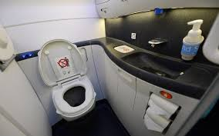

Figure : <http://articles.latimes.com/2012/dec/18/news/la-trb-potty-airline-seats-20121217>

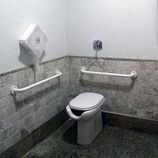

Figure : <http://www.decoracaoeprojetos.com.br/projeto-de-banheiro-para-deficientes/>

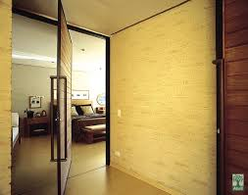

Figure : <http://www.vitrinenews.com.br/vitrine/index.php?option=com_content&view=category&layout=blog&id=33&Itemid=45&limitstart=40>

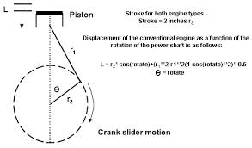

Figure : <http://www.wisemanengine.com/equations.htm>

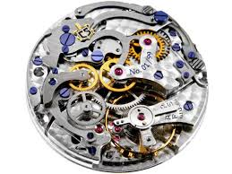

Figure : <http://www.menshealth.co.uk/living/gear/watch-movements-explained>

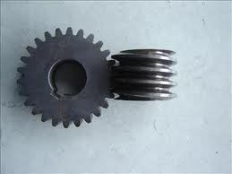

Figure : <http://cerejasrenovaveis.tumblr.com/>

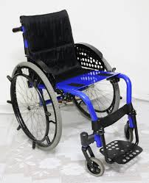

Figure : <http://maonarodablog.com.br/2010/06/07/tokleve-milenium-sport-avaliacao/>

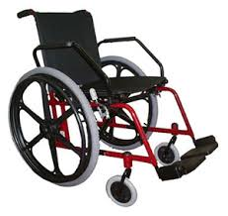

Figure : <http://www.dietz-reha.com/dietz_de/eclipse>

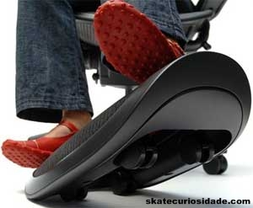

Figure : <http://www.grabc4d.org/viewthread.php?tid=10156>



Figure : <http://www.yesillerrulman.com/staf_lsk_ome_lineer_kizakli_araba_ray.html>

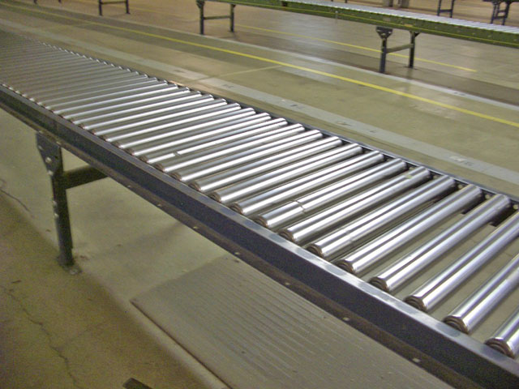

Figure : <http://qdtmzdhsb.cn.gongchang.com/product/d27215965.html>

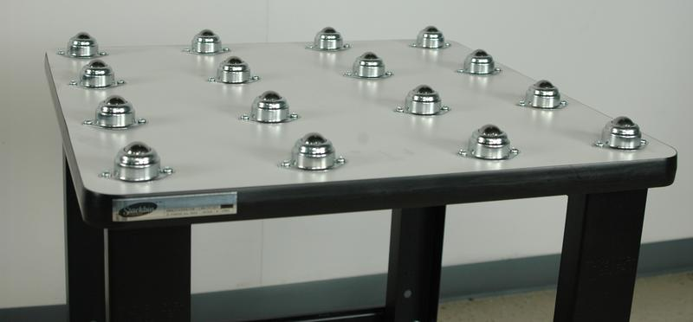

Figure : http://www.stackbin.com/categories/ball-transfer-tables/